**Python and Bio-Python**

BID-501 Python for Bioinformatics

**Assignment 1**

**Practical solving:**

1.     W.a.p for demonstrating the usage of built-in number functions in Python

Answer: Some of the Built-in Number Functions in python are-

1. max = The largest of its arguments: the value closest to positive infinity

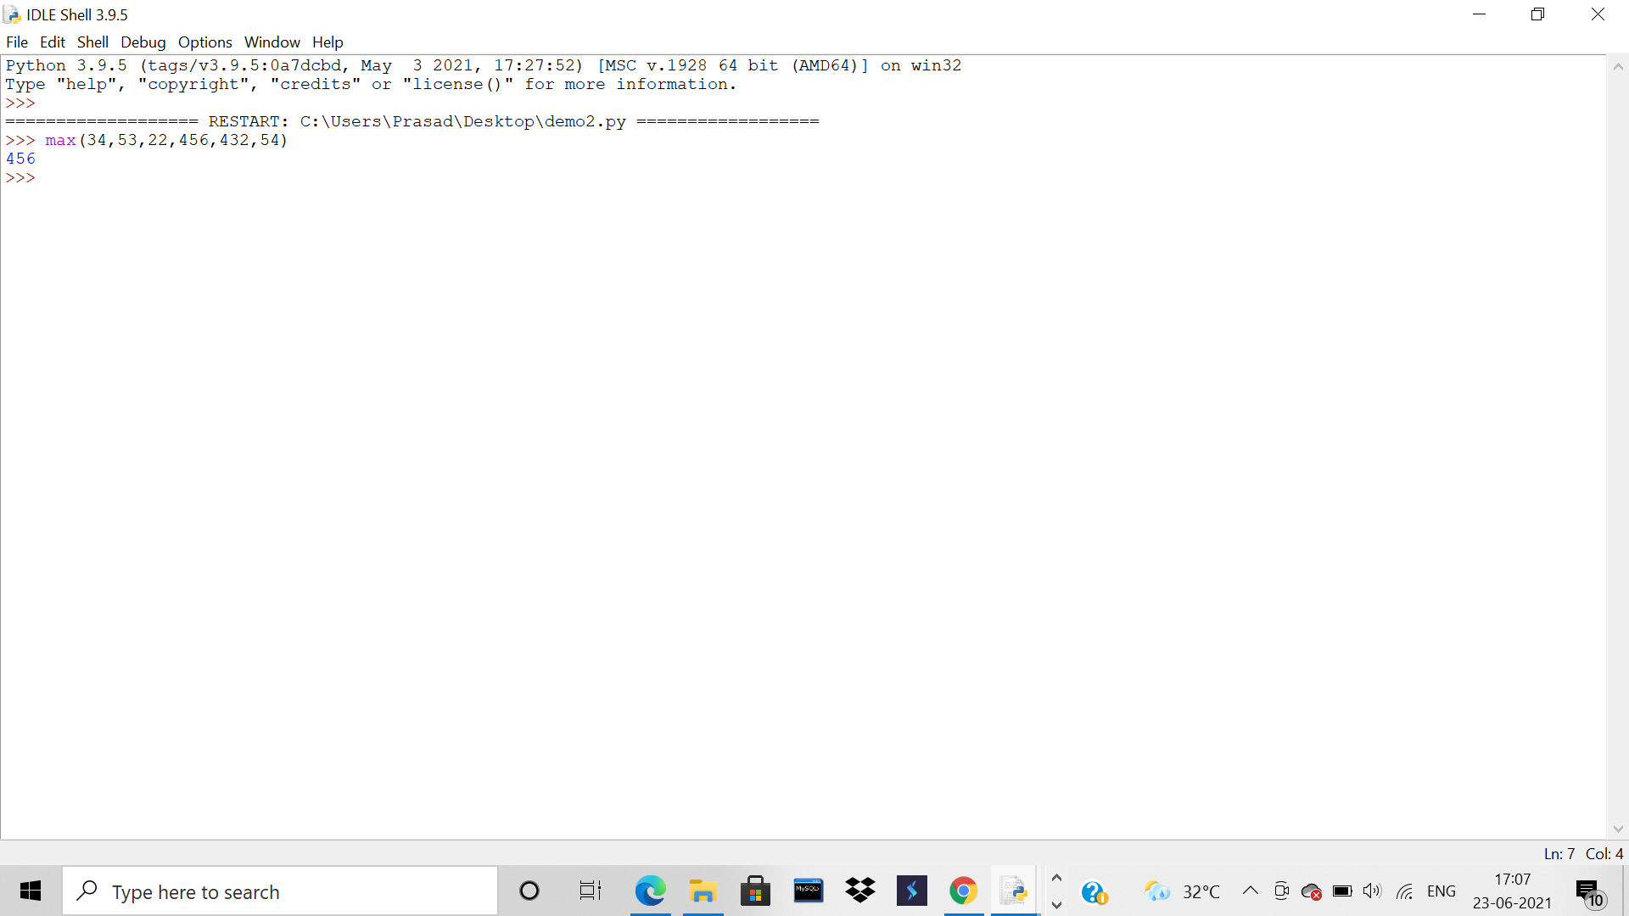

1. min = The smallest of its arguments: the value closest to negative infinity

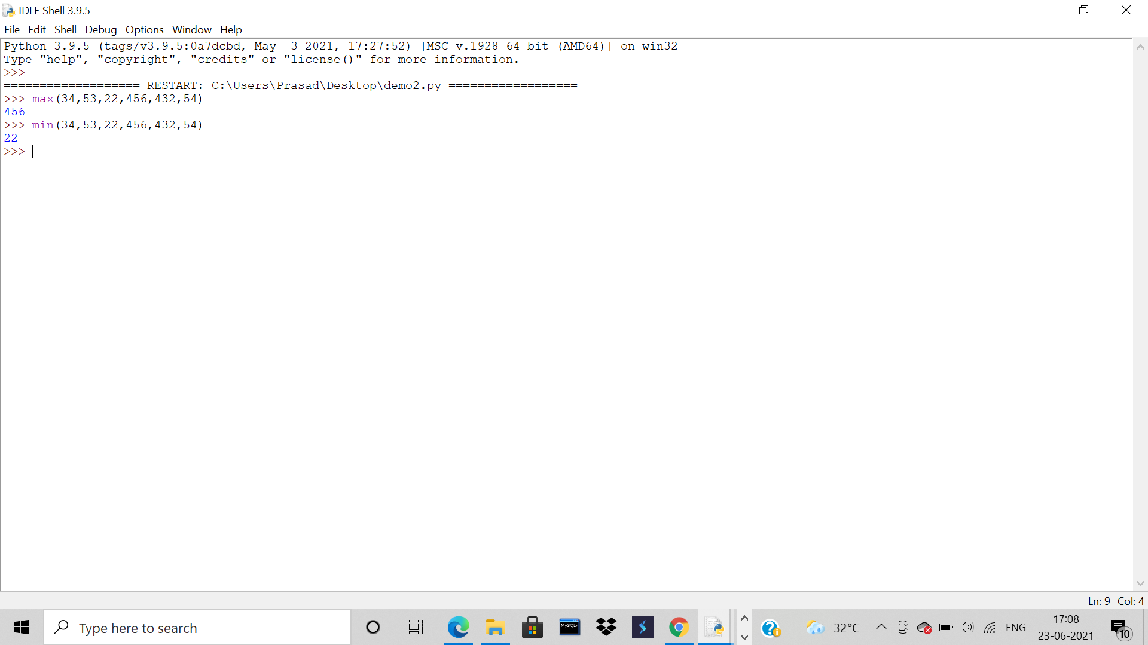

1. round = x rounded to n digits from the decimal point. Python rounds away from zero as a tie-breaker: round(0.5) is 1.0 and round(-0.5) is -1.0.

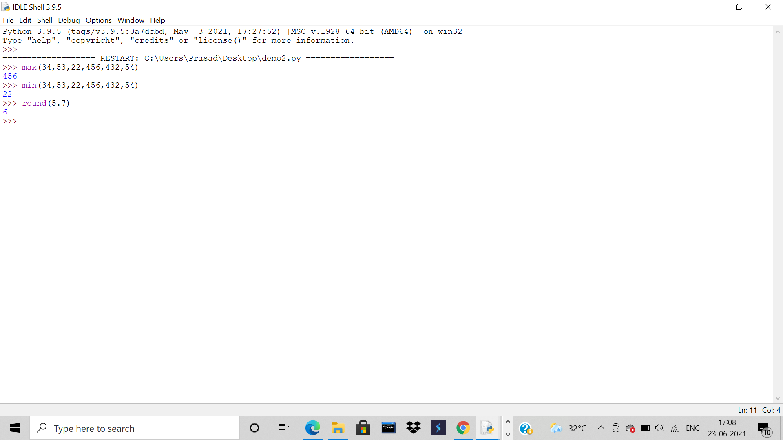

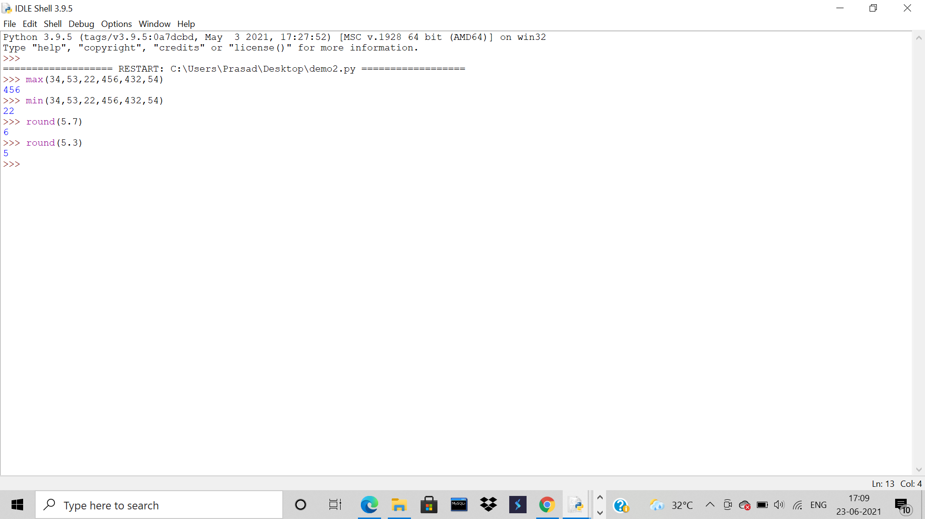

2.     W.a.p for demonstrating the usage of escape characters in strings.

Answer: To insert characters that are illegal in a string, use an escape character. An escape character is a backslash \ followed by the character you want to insert. So basically, placing a ‘\’ in front of one of these special or reserved characters will tell Python to just treat it as text, ensuring your code is valid and behaves as you’d expect.

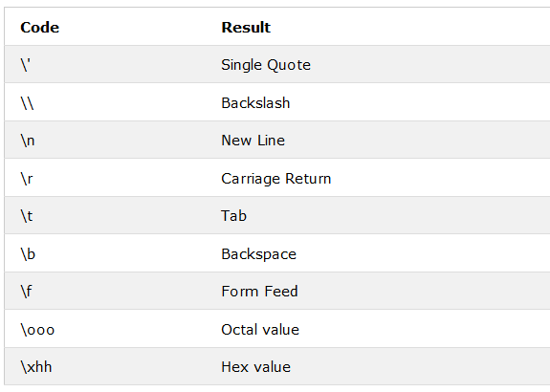

1. Code = \n

Output: \n is used to print word on next line.

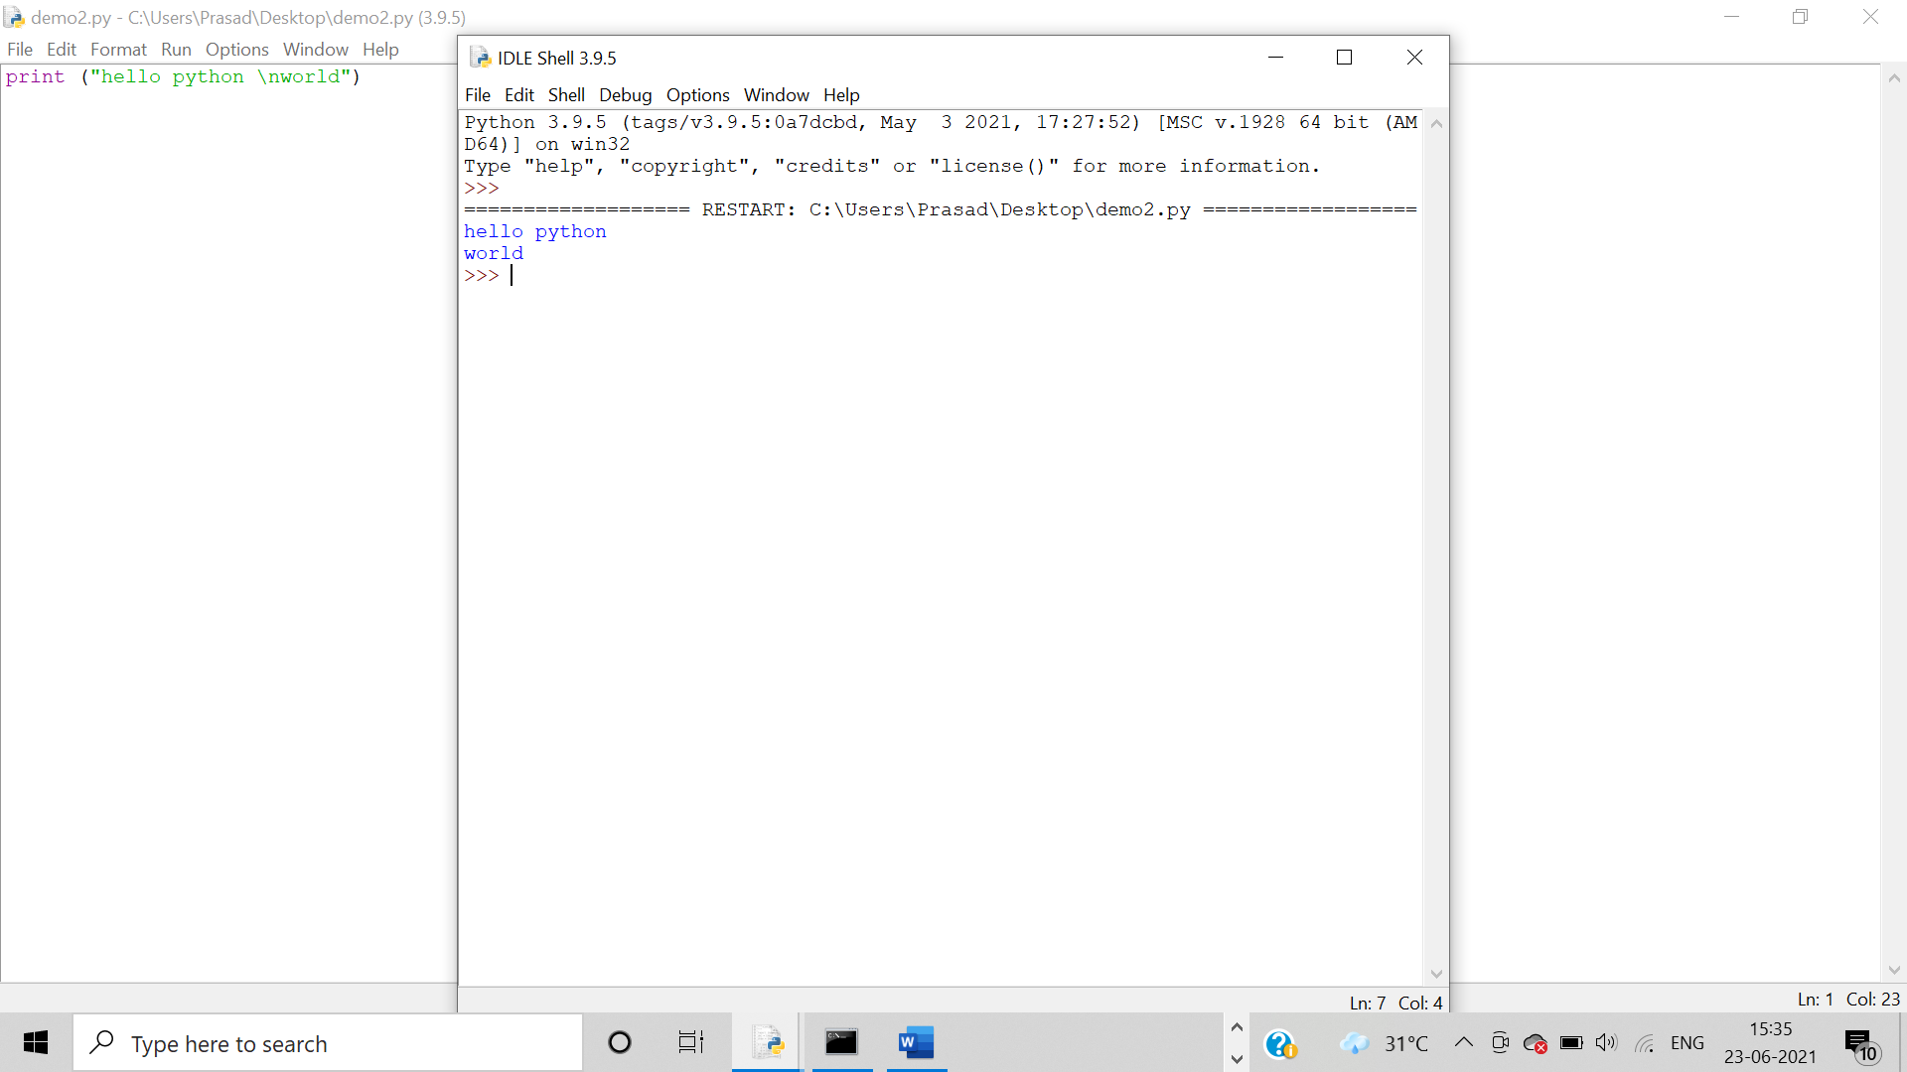

1. Code = \\

Output: **\\**is used to print a single backslash.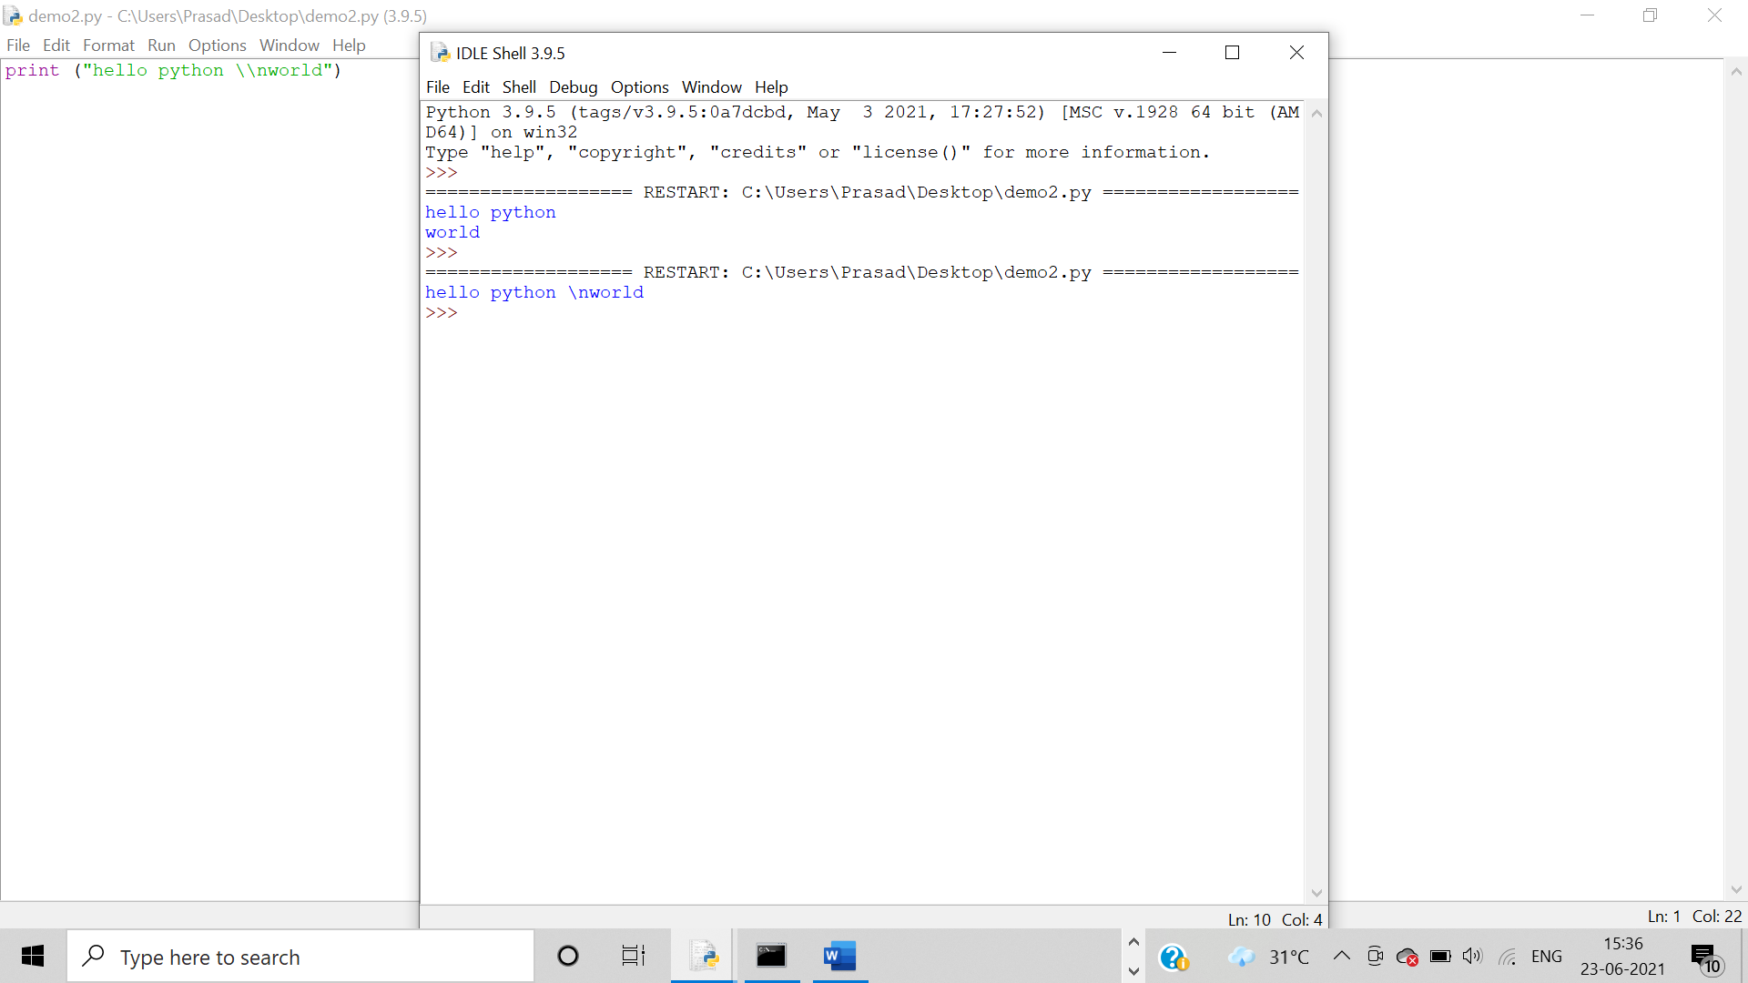

1. Code = \

Output:

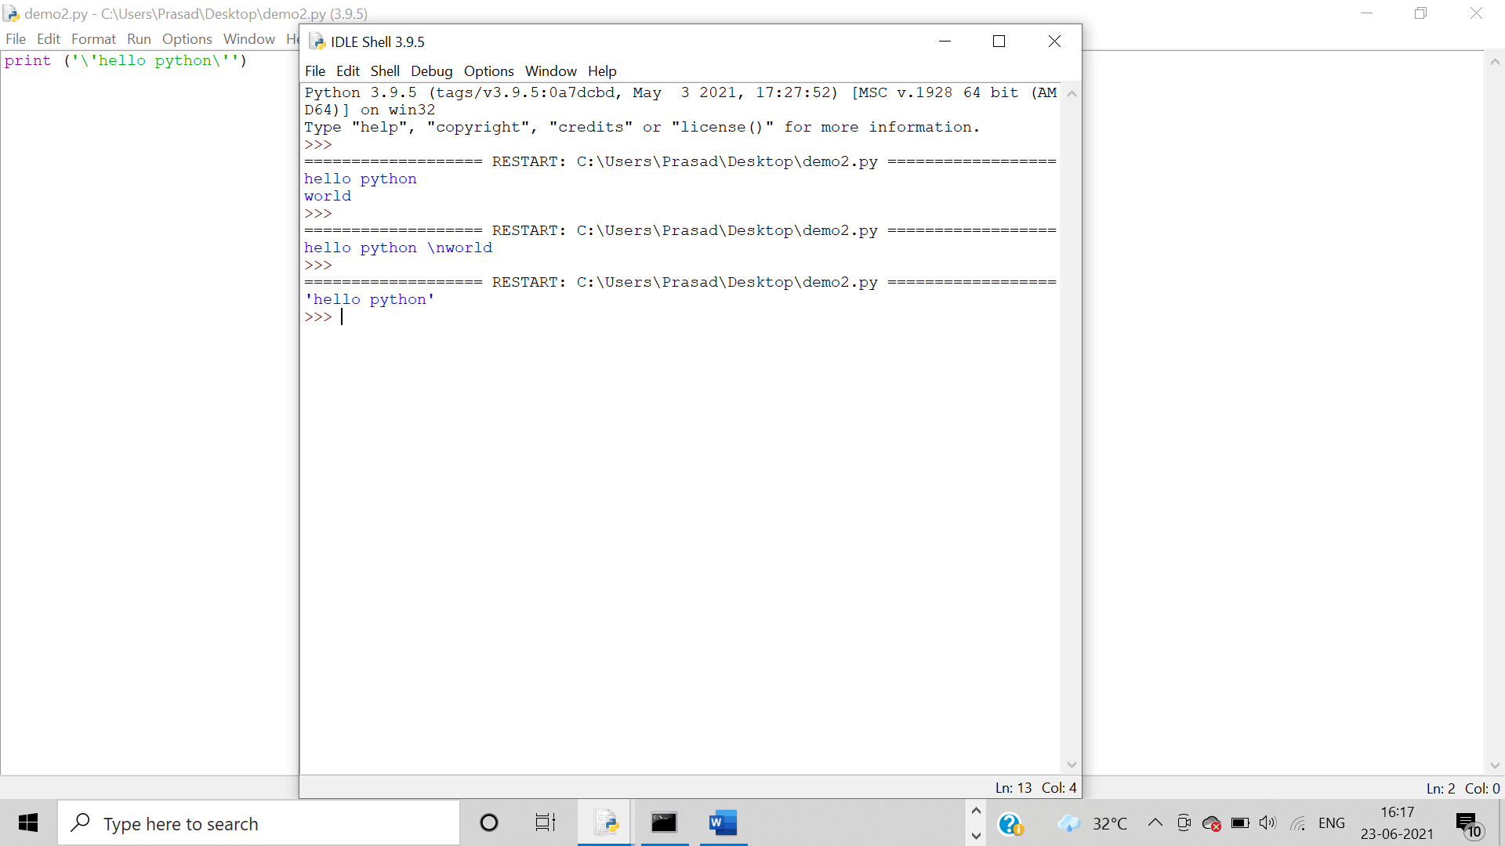

1. Code =\t

Output: **“\t”** is usedto get space between the words.

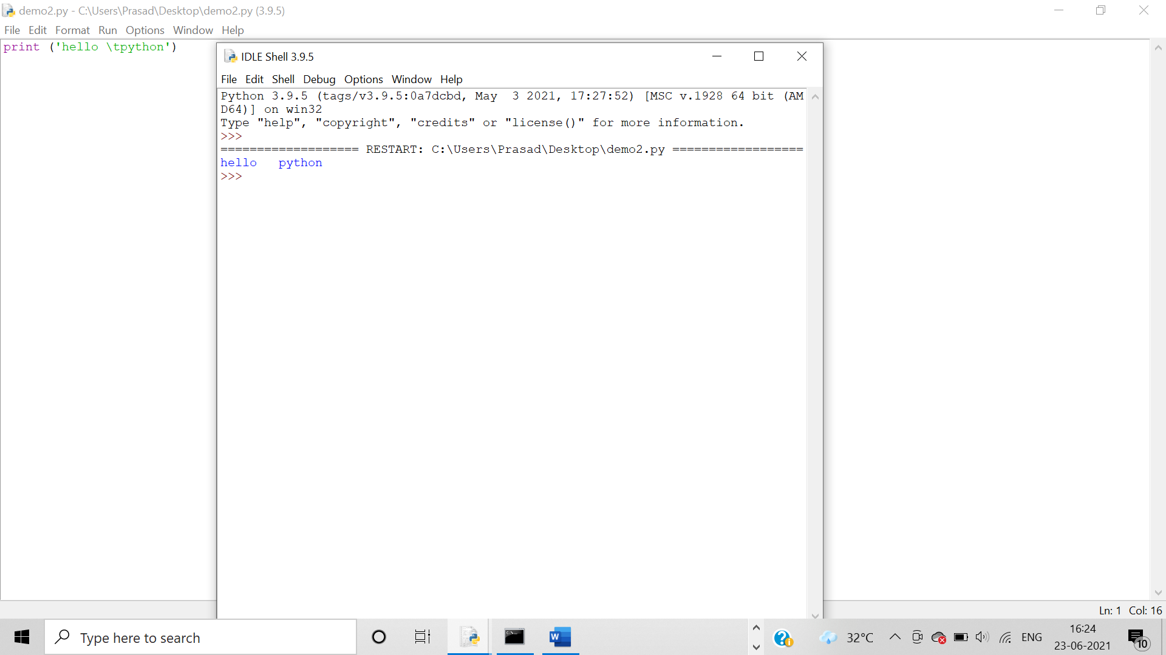

1. Code = \b

Output: **“\b”**is usedto remove the space between the words in Python.

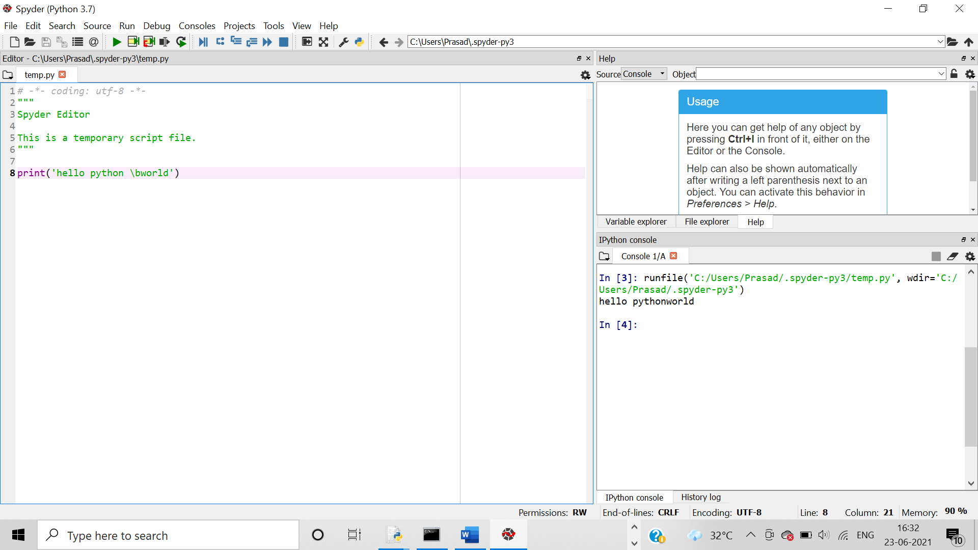

1. Code = \r Carriage return

Output:

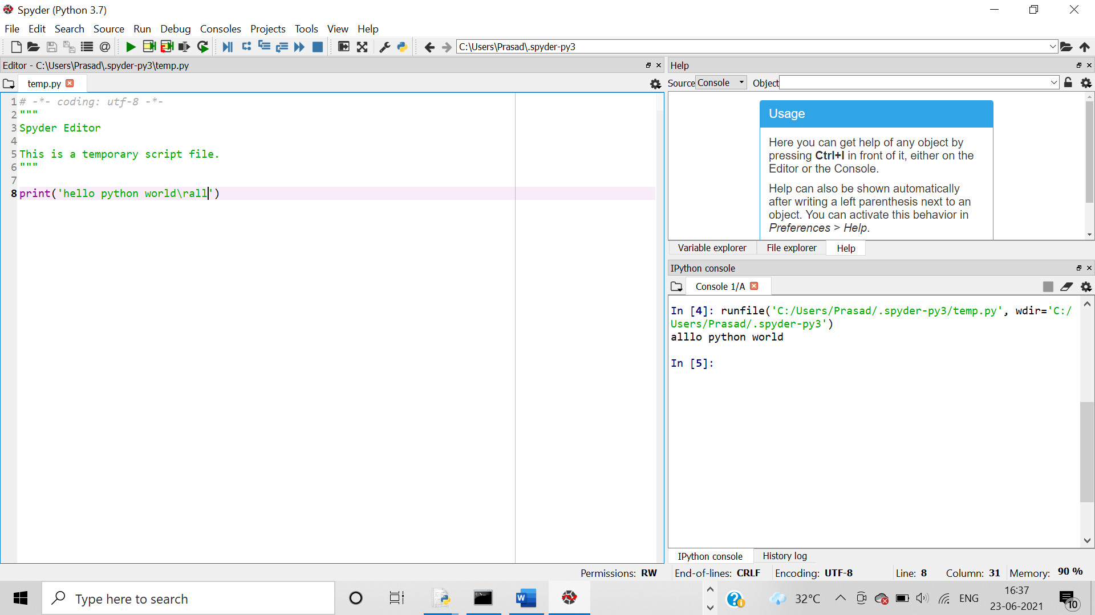

1. Code = \ooo Octal Values (\110\145\154\154\157)

Output:

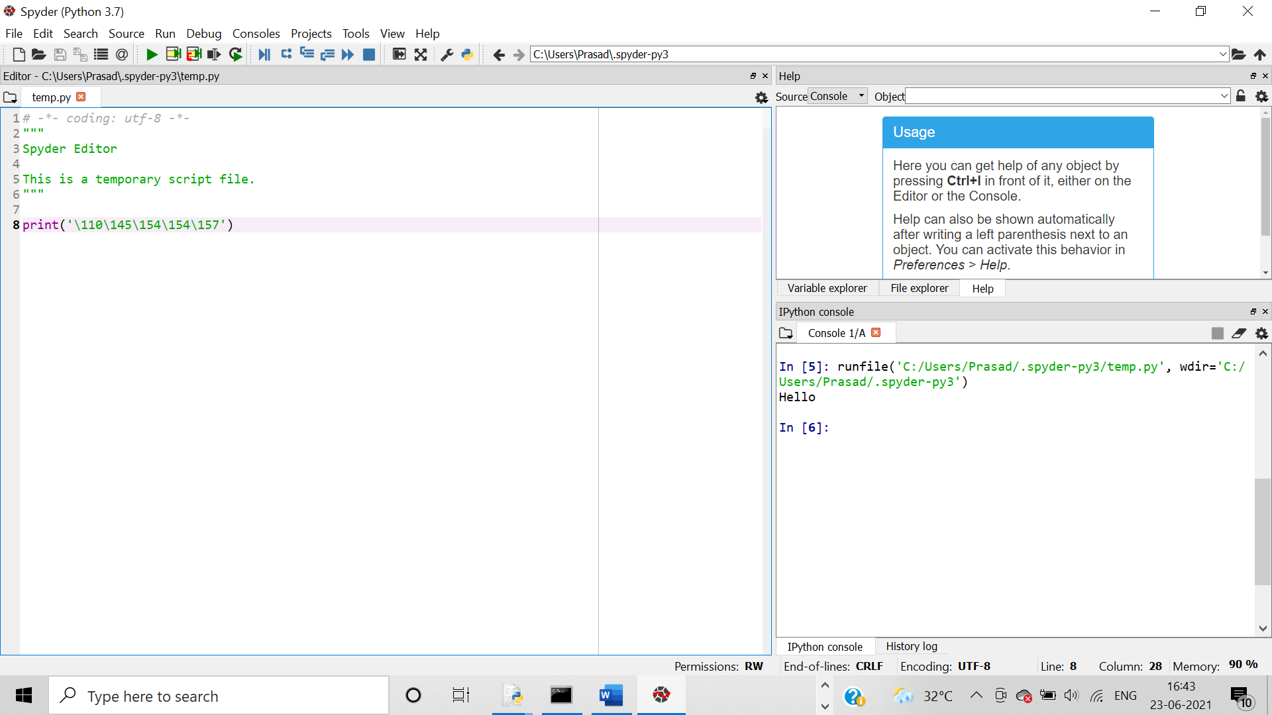

1. Code = \xhh Hex value (\x48\x65\x6c\x6c\x6f)

Output:

